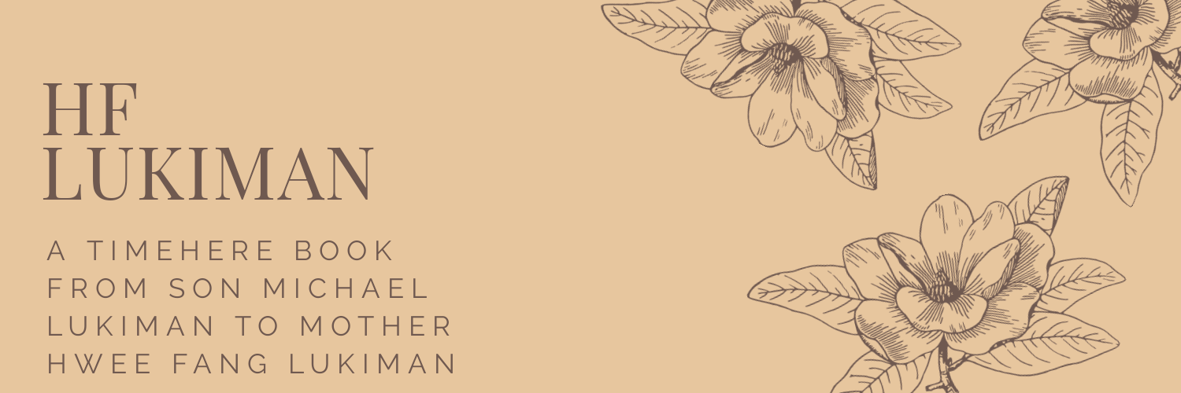

This journal is meant to be a container for a trip down memory lane. It's supposed to be great at sparking stories and conversations between people close to you. It can even document a life. You can fill it out at any pace. The writer can skip around, but it starts from most recent because those are the memories we remember more directly. Diagrams and pointers can be drawn on the margin for a more robust form of journaling.

# Demo

These are the remarks and the thoughts about *Demo. You can add drawings / diagrams here.*

This March I learned how to play mahjong. I left position at ____ and started a  
new type of job at ____. When I first started I remember this story where _____.  
My daily routine consisted of _____. A cool TV series that I remember watching  
around this time was ______. I traveled around the city and saw ____ in summer...

# 2020

These are the remarks and the thoughts about *2020. You can add drawings / diagrams here.*

This year has not happened yet, so write what you look forward to!

# 2019

These are the remarks and the thoughts about *2019. You can add drawings / diagrams here.*

The part about this year I was most grateful for:



# 2018

These are the remarks and the thoughts about *2018. You can add drawings / diagrams here.*

The part about this year I was most grateful for:

# 2017

These are the remarks and the thoughts about *2017. You can add drawings / diagrams here.*

The part about this year I was most grateful for:

# 2016

These are the remarks and the thoughts about *2016. You can add drawings / diagrams here.*

The part about this year I was most grateful for:



# 2015

These are the remarks and the thoughts about *2015. You can add drawings / diagrams here.*

The part about this year I was most grateful for:

# 2014

These are the remarks and the thoughts about *2014. You can add drawings / diagrams here.*

The part about this year I was most grateful for:

# 2013

These are the remarks and the thoughts about *2013. You can add drawings / diagrams here.*

The part about this year I was most grateful for:



# 2012

These are the remarks and the thoughts about *2012. You can add drawings / diagrams here.*

The part about this year I was most grateful for:

# 2011

These are the remarks and the thoughts about *2011. You can add drawings / diagrams here.*

The part about this year I was most grateful for:

# 2010

These are the remarks and the thoughts about *2010. You can add drawings / diagrams here.*

The part about this year I was most grateful for:



# 2009

These are the remarks and the thoughts about *2009. You can add drawings / diagrams here.*

The part about this year I was most grateful for:

# 2008

These are the remarks and the thoughts about *2008. You can add drawings / diagrams here.*

The part about this year I was most grateful for:

# 2007

These are the remarks and the thoughts about *2007. You can add drawings / diagrams here.*

The part about this year I was most grateful for:



# 2006

These are the remarks and the thoughts about *2006. You can add drawings / diagrams here.*

The part about this year I was most grateful for:

# 2005

These are the remarks and the thoughts about *2005. You can add drawings / diagrams here.*

The part about this year I was most grateful for:

# 2004

These are the remarks and the thoughts about *2004. You can add drawings / diagrams here.*

The part about this year I was most grateful for:



# 2003

These are the remarks and the thoughts about *2003. You can add drawings / diagrams here.*

The part about this year I was most grateful for:

# 2002

These are the remarks and the thoughts about *2002. You can add drawings / diagrams here.*

The part about this year I was most grateful for:

# 2001

These are the remarks and the thoughts about *2001. You can add drawings / diagrams here.*

The part about this year I was most grateful for:



# 2000

These are the remarks and the thoughts about *2000. You can add drawings / diagrams here.*

The part about this year I was most grateful for:

# 1999

These are the remarks and the thoughts about *1999. You can add drawings / diagrams here.*

The part about this year I was most grateful for:

# 1998

These are the remarks and the thoughts about *1998. You can add drawings / diagrams here.*

The part about this year I was most grateful for:



# 1997

These are the remarks and the thoughts about *1997. You can add drawings / diagrams here.*

The part about this year I was most grateful for:

# 1996

These are the remarks and the thoughts about *1996. You can add drawings / diagrams here.*

The part about this year I was most grateful for:

# 1995

These are the remarks and the thoughts about *1995. You can add drawings / diagrams here.*

The part about this year I was most grateful for:



# 1994

These are the remarks and the thoughts about *1994. You can add drawings / diagrams here.*

The part about this year I was most grateful for:

# 1993

These are the remarks and the thoughts about *1993. You can add drawings / diagrams here.*

The part about this year I was most grateful for:

# 1992

These are the remarks and the thoughts about *1992. You can add drawings / diagrams here.*

The part about this year I was most grateful for:



# 1991

These are the remarks and the thoughts about *1991. You can add drawings / diagrams here.*

The part about this year I was most grateful for:

# 1990

These are the remarks and the thoughts about *1990. You can add drawings / diagrams here.*

The part about this year I was most grateful for:

# 1989

These are the remarks and the thoughts about *1989. You can add drawings / diagrams here.*

The part about this year I was most grateful for:



# 1988

These are the remarks and the thoughts about *1988. You can add drawings / diagrams here.*

The part about this year I was most grateful for:

# 1987

These are the remarks and the thoughts about *1987. You can add drawings / diagrams here.*

The part about this year I was most grateful for:

# 1986

These are the remarks and the thoughts about *1986. You can add drawings / diagrams here.*

The part about this year I was most grateful for:



# 1985

These are the remarks and the thoughts about *1985. You can add drawings / diagrams here.*

The part about this year I was most grateful for:

# 1984

These are the remarks and the thoughts about *1984. You can add drawings / diagrams here.*

The part about this year I was most grateful for:

# 1983

These are the remarks and the thoughts about *1983. You can add drawings / diagrams here.*

The part about this year I was most grateful for:



# 1982

These are the remarks and the thoughts about *1982. You can add drawings / diagrams here.*

The part about this year I was most grateful for:

# 1981

These are the remarks and the thoughts about *1981. You can add drawings / diagrams here.*

The part about this year I was most grateful for:

# 1980

These are the remarks and the thoughts about *1980. You can add drawings / diagrams here.*

The part about this year I was most grateful for:



# 1979

These are the remarks and the thoughts about *1979. You can add drawings / diagrams here.*

The part about this year I was most grateful for:

# 1978

These are the remarks and the thoughts about *1978. You can add drawings / diagrams here.*

The part about this year I was most grateful for:

# 1977

These are the remarks and the thoughts about *1977. You can add drawings / diagrams here.*

The part about this year I was most grateful for:



# 1976

These are the remarks and the thoughts about *1976. You can add drawings / diagrams here.*

The part about this year I was most grateful for:

# 1975

These are the remarks and the thoughts about *1975. You can add drawings / diagrams here.*

The part about this year I was most grateful for:

# 1974

These are the remarks and the thoughts about *1974. You can add drawings / diagrams here.*

The part about this year I was most grateful for:



# 1973

These are the remarks and the thoughts about *1973. You can add drawings / diagrams here.*

The part about this year I was most grateful for:

# 1972

These are the remarks and the thoughts about *1972. You can add drawings / diagrams here.*

The part about this year I was most grateful for:

# 1971

These are the remarks and the thoughts about *1971. You can add drawings / diagrams here.*

The part about this year I was most grateful for:



# 1970

These are the remarks and the thoughts about *1970. You can add drawings / diagrams here.*

The part about this year I was most grateful for:

# 1969

These are the remarks and the thoughts about *1969. You can add drawings / diagrams here.*

The part about this year I was most grateful for:

# 1968

These are the remarks and the thoughts about *1968. You can add drawings / diagrams here.*

The part about this year I was most grateful for:



# 1967

These are the remarks and the thoughts about *1967. You can add drawings / diagrams here.*

The part about this year I was most grateful for:

# 1966

These are the remarks and the thoughts about *1966. You can add drawings / diagrams here.*

The part about this year I was most grateful for:

# 1965

These are the remarks and the thoughts about *1965. You can add drawings / diagrams here.*

The part about this year I was most grateful for:



# 1964

These are the remarks and the thoughts about *1964. You can add drawings / diagrams here.*

The part about this year I was most grateful for:

# 1963

These are the remarks and the thoughts about *1963. You can add drawings / diagrams here.*

The part about this year I was most grateful for:

# 1962

These are the remarks and the thoughts about *1962. You can add drawings / diagrams here.*

The part about this year I was most grateful for:



# 1961

These are the remarks and the thoughts about *1961. You can add drawings / diagrams here.*

The part about this year I was most grateful for:

# 1960

These are the remarks and the thoughts about *1960. You can add drawings / diagrams here.*

The part about this year I was most grateful for:

# 1959

These are the remarks and the thoughts about *1959. You can add drawings / diagrams here.*

The part about this year I was most grateful for:



# 1958

These are the remarks and the thoughts about *1958. You can add drawings / diagrams here.*

The part about this year I was most grateful for:

This is what happened in my childhood and before I was born: